Practical: 01

AIM: Dealing with Data using Numpy, Pandas, Statistics library

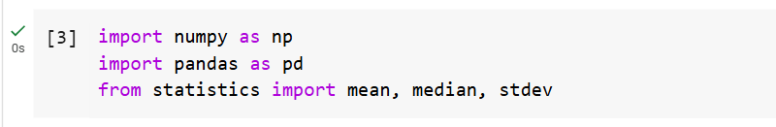

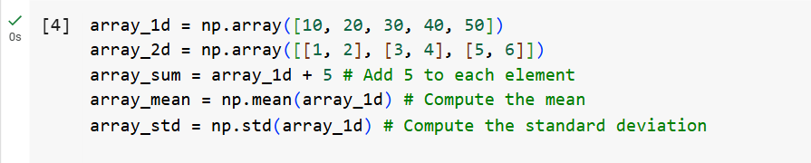

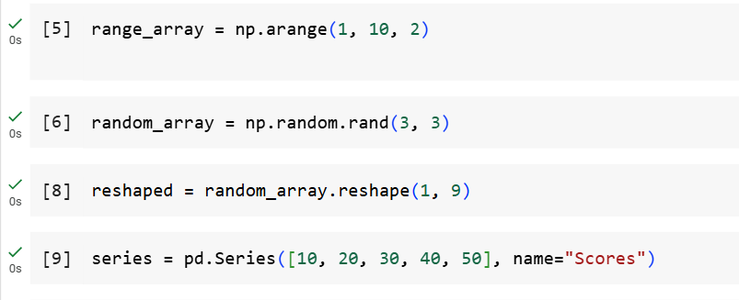

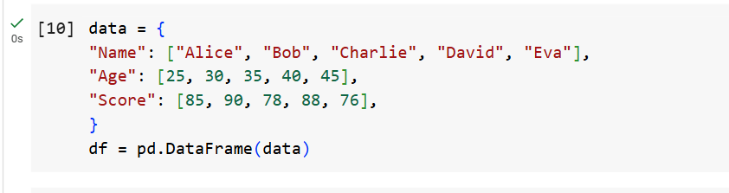

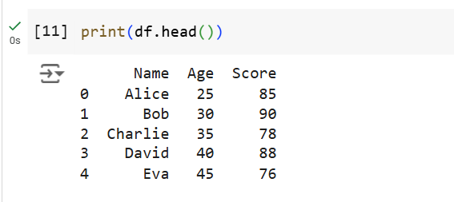

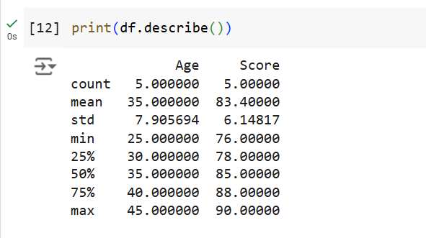

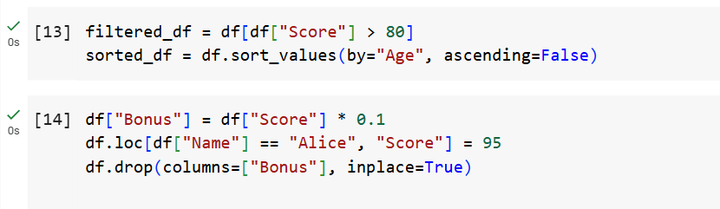

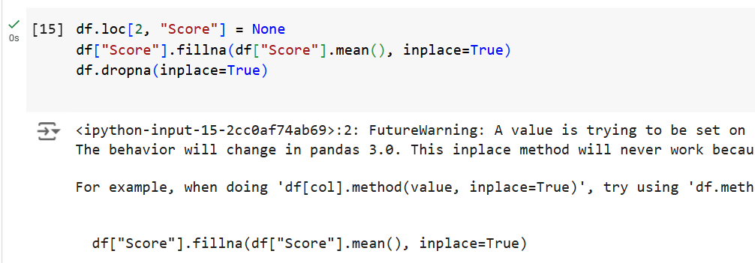

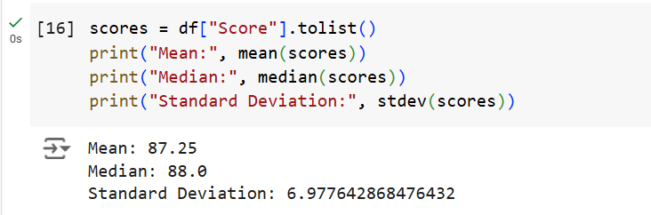

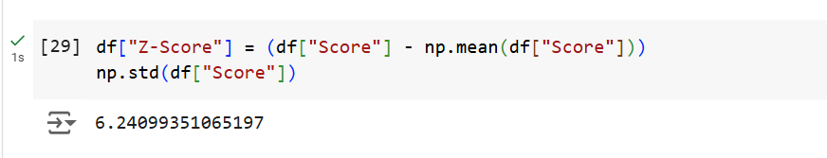

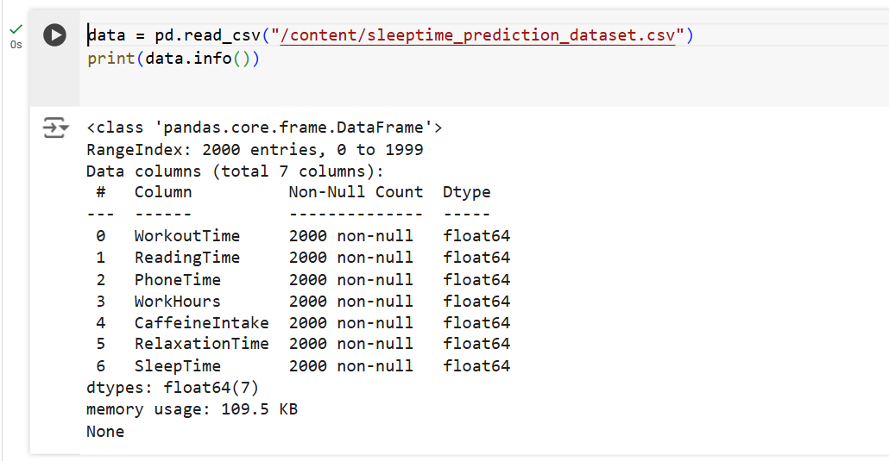

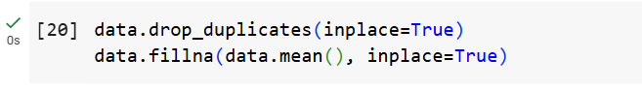

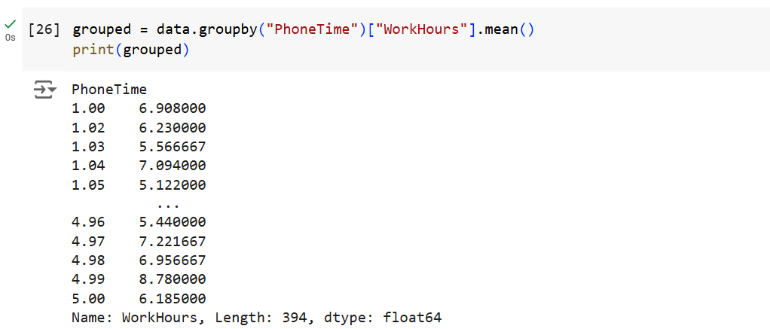

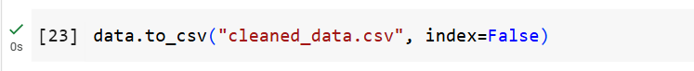

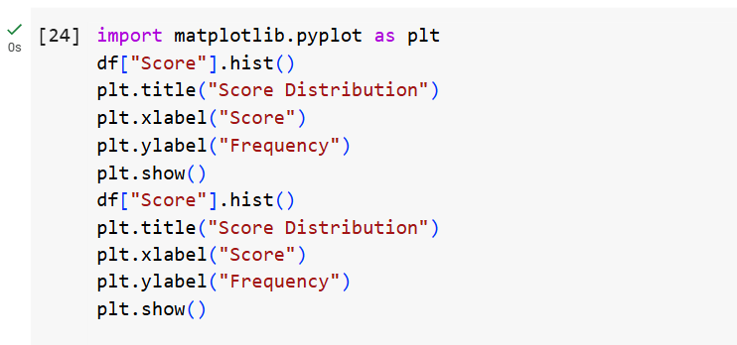

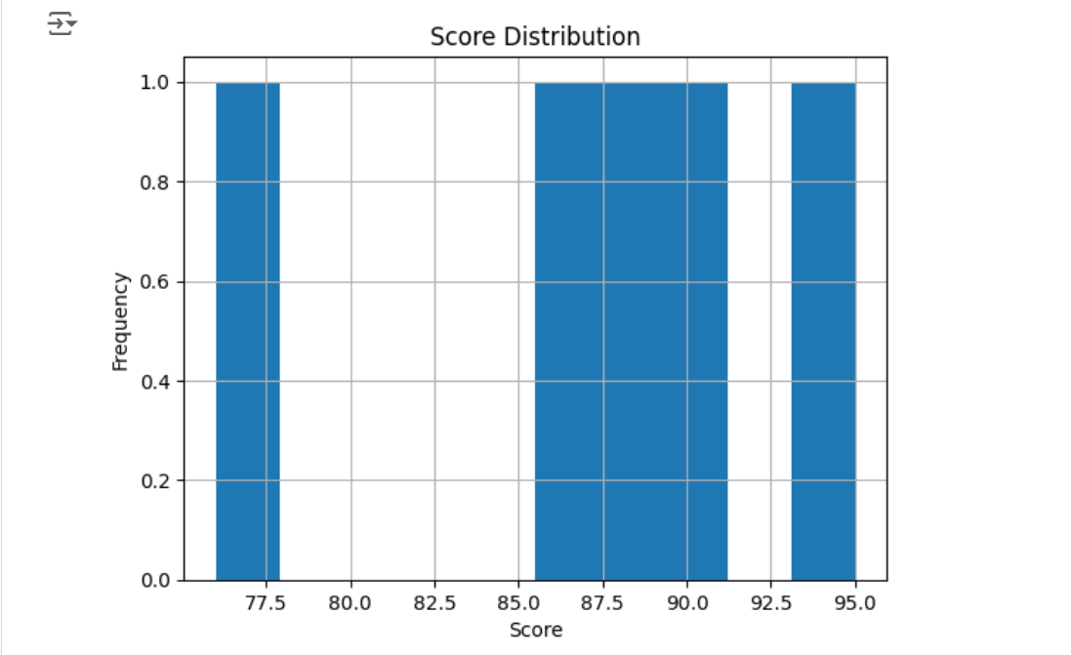

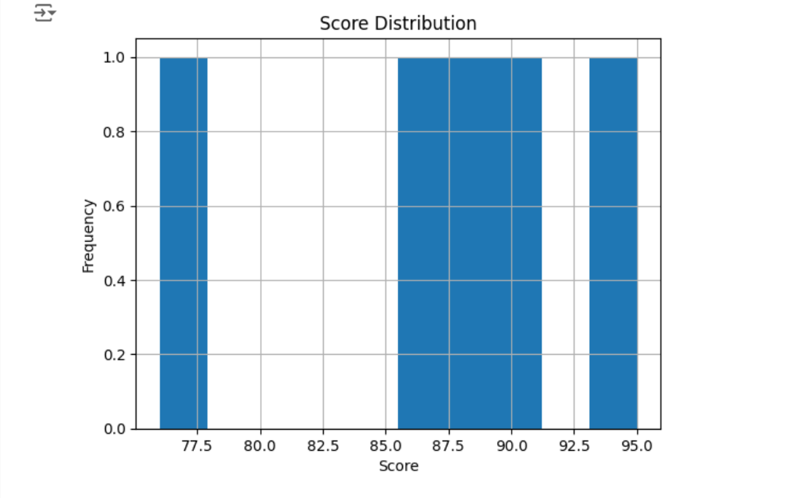

Practical: 02

AIM: Data Analysis & Visualization on Diwali Sales Dataset.



Practical: 06

AIM: Write a program to demonstrate the working of the decision tree based ID3 algorithm.
Description: -
The ID3 algorithm is a popular algorithm used to create a Decision Tree by selecting the attribute that maximizes the information gain at each node.

This program will :

- Build a simple dataset.
- Implement the ID3 algorithm to construct the decision tree.
- Print the tree structure
The ID3 (Iterative Dichotomiser 3) algorithm is a popular method used to build Decision Trees. It splits the data based on the attribute that provides the highest Information Gain at each step, and continues until the data is fully classified or no further splits can be made.

Entropy is a measure of uncertainty or impurity in the dataset. It tells us how mixed or pure a dataset is with respect to its labels. The formula for entropy is:
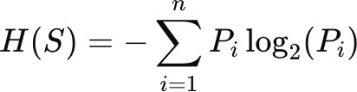
Where:
  - Pi is the probability of label i.

Information Gain is the reduction in entropy after a dataset is split on an attribute. It is given by: -

The attribute with the highest information gain is chosen as the best attribute to split the data

The ID3 algorithm builds the decision tree recursively:
- Select the best attribute to split the data.
- Create a node for the attribute.

- Split the data into subsets based on the values of the attribute.
- Repeat the process for each subset.
The tree is printed in a readable format using a recursive function.

Code: -

import pandas as pd

class DecisionTreeID3:
def __init__(self):
self.tree = {}

def fit(self, X, y):
self.tree = self._build_tree(X, y)

def _build_tree(self, X, y):
if len(set(y)) == 1:
return y.iloc[0]
root = X.columns[0]
tree = {root: {}}
for value in X[root].unique():
subset_X = X[X[root] == value].drop(columns=[root])
subset_y = y[X[root] == value]
tree[root][value] = self._build_tree(subset_X, subset_y)

return tree

def print_tree(self, tree=None, depth=0):
if tree is None:
tree = self.tree

for key, value in tree.items():
print("\t" * depth + str(key))
if isinstance(value, dict):
self.print_tree(value, depth + 1)
else:
print("\t" * (depth + 1) + f"Label: {value}")

if __name__ == "__main__":
data = {
'Outlook': ['Sunny', 'Sunny', 'Overcast', 'Rain', 'Rain', 'Rain', 'Overcast', 'Sunny', 'Sunny', 'Rain'],
'Temperature': ['Hot', 'Hot', 'Hot', 'Mild', 'Cool', 'Cool', 'Mild', 'Mild', 'Hot', 'Mild'],
'Humidity': ['High', 'High', 'High', 'High', 'Normal', 'Normal', 'Normal', 'High', 'Normal', 'Normal'],
'Wind': ['Weak', 'Strong', 'Weak', 'Weak', 'Weak', 'Strong', 'Strong', 'Weak', 'Strong', 'Weak'],
'Play': ['No', 'No', 'Yes', 'Yes', 'Yes', 'No', 'Yes', 'No', 'Yes', 'Yes']
}

df = pd.DataFrame(data)
X = df.drop(columns=['Play'])
y = df['Play']

model = DecisionTreeID3()
model.fit(X, y)

print("Decision Tree:")
model.print_tree()

print("Decision Tree Hardi Chauhan 2303031057013:")
model.print_tree()

Output: -

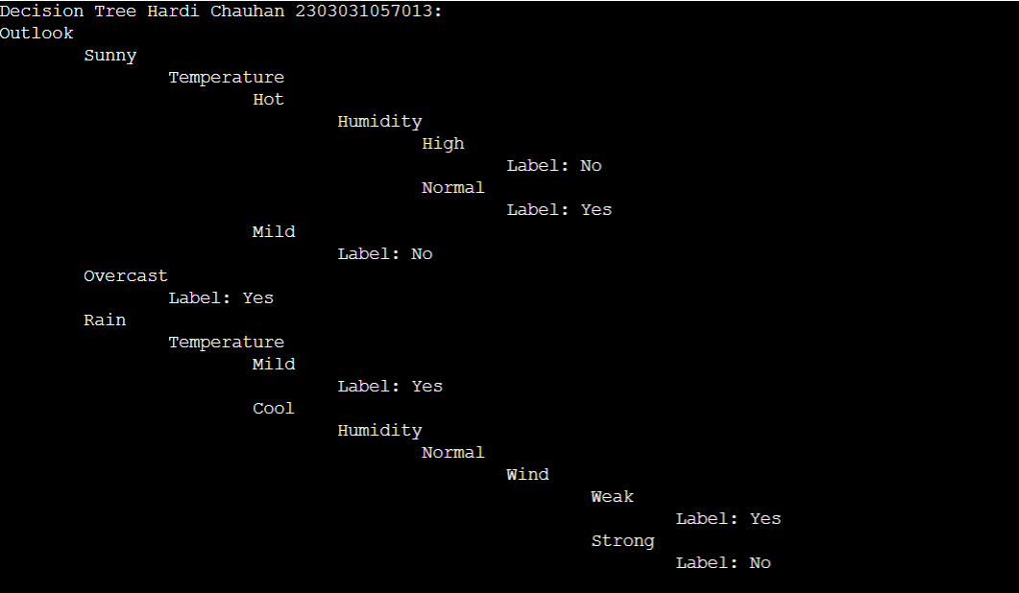

Decision Tree: -
